RICHMOND COUNTY SHERIFF’S OFFICE

Sheriff Richard Roundtree Respect • Integrity • Teamwork • Excellence

FOUR YEAR STRATEGIC PLAN
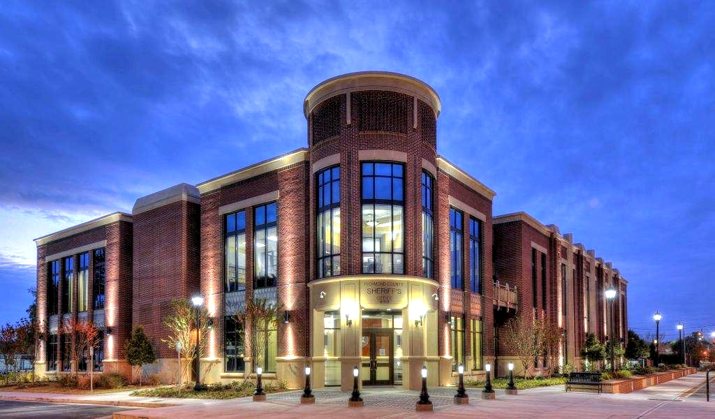

TABLE OF CONTENTS

Introduction 3

Vision of the Sheriff 4
Strategic Planning Methodology 6

Where We Are Today 8

Vision Statement 13

Mission Statement 13

Values 13

Strategic Goals 15

Goal 1: Reduce Violent Crime and Victimization………………........…….………………… 16
Goal 2: Building Trust and relationships in the community………………………………. 17
Goal 3: Investment in Human Capital………………………………………………………………. 18
Goal 4: Integrate, Expand and Harness the Use of Technology for maximum effectiveness and efficiency…………………………………………………………………………….. 19
Goal 5: Use SMART Policing with Educational and Cyber Communities to maximize effectiveness and efficiency ……………………………………………………….. 20

INTRODUCTION

The Richmond County Sheriff’s Office is a progressive, full-service law enforcement agency that continually seeks to meet the challenges of serving and protecting the citizens and visitors of a growing and vibrant community. To help meet those challenges in an effective and efficient manner, the agency practices the philosophy of proactive strategic planning.

Simply put, strategic planning is a process in which an organization addresses four (4) fundamental questions:

- Where are we now? (Strengths, Weaknesses, Opportunities, and Threats)
- Where do we want to be? (4 years from now)
- How will we get there? (Goals, objectives and strategies)
- How will we know when we get there? (What performance metrics are in place to measure progress and outcomes?)

Strategic planning helps an organization align its goals, outcomes and key success indicators, which at the same time serving as a reference point for budgetary prioritization of mission-critical initiatives.

This plan is intended to serve as a year-round operational guide that is updated as necessary to reflect the ever-changing environments in which the RCSO must operate.

Division commanders are required to develop and produce yearly goals and objectives for their respective divisions. The development of those goals and objectives must always support this strategic plan. The members of the RCSO are committed to improving the quality of life for everyone in our community. This strategic plan shall serve as the roadmap to guide the agency toward achieving its mission.

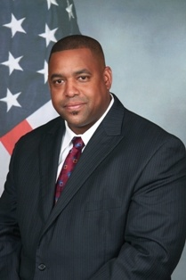
From the Sheriff

My new covenant with the community reaffirms my commitment to the strategic vison of a safe and secure Augusta. We have made great progress in the journey over the last four years and fulfilled the promises of my first covenant with the community. We must continue to build on our successes in the pursuit of “one team, one dream” for our community and your Sheriff’s Office.
These are my top five commitments of the new covenant that build on our accomplishments and we will pursue these strategies in the next four years.
- Reduce and Prevent Crime Victimization:
Our #1 priority will be the reduction of violent crime in our community and overall crime reduction is the #2 priority. We must also reduce the perception of crime as well.
- Building Trust and Relationships in the Community
Continue to build on the community policing philosophy with additional community outreach to maximize community engagement. We will also continue to increase our accountability and transparency.
- Investment in Human Capital
Our #1 resource is our people. The Richmond County Sheriff’s Office will recruit the best, retain the best and retire the best. Our personnel are the “best of the best” and we will seek better pay, developmental opportunities, advanced training, mentoring and equipment for our team. We will practice internal legitimacy and procedural justice. If we treat our employees as they deserve, they will treat citizens as they deserve.
- Integrate, Expand and Harness the Use of Technology for maximum effectiveness and efficiency
We will initiate a county-wide camera program starting in the downtown district and then expand in the future. We will update the radio system and body worn cameras, obtain facial recognition/predictive policing software and an internet based complaint system for citizens.
- Use SMART Policing with Educational and Cyber Communities to maximize effectiveness and efficiency
We will partner with our Educational and Cyber Communities to develop “cutting edge” research and analytics to enhance our intelligence led policing, emergency management, and other key components of keeping our community safe.

STRATEGIC PLANNING METHODOLOGY

The strategic planning methodology used by the RCSO revolves around both an annual and operational tri-annual planning cycle. Those cycles include the following key elements:

Vision of the Sheriff
The sheriff shall meet with his Command Staff and share his vision for the coming year(s).

Completion of SWOT Analysis (Strengths, Weaknesses, Opportunities and Threats)
A SWOT Analysis is a comprehensive assessment of internal and external environments that affect the RCSO and its ability to provide law enforcement services.

Command Staff Review of SWOT Analysis
Command Staff reviews the results of the SWOT Analysis as a group to determine the future path of the agency.

Publish and Implement the Plan
The Multi-Year Strategic Plan is supported by the annual goals and objectives developed by each division commander. The strategic plan is also part of the annual budget process and is linked to the fiscal year which runs from January 1 – December 31.

Quarterly Follow-up Assessments
Bureau and Division Commanders should conduct quarterly follow-up assessments to determine progress made towards the attainment of annual goals and objectives. Modifications to the multi-year Strategic Plan can be made by following these quarterly assessments as needed.

WHERE WE ARE TODAY

The RCSO is a full-service Sheriff’s Office, comprised of 750 authorized employees, providing a wide range of law enforcement services to the citizens and visitors of Richmond County, Georgia. These services include uniform patrol and special operations, traffic safety and enforcement, investigations, crime prevention programs and collaborative partnerships with multiple stakeholders throughout the CSRA.

ORGANIZATIONAL STRUCTURE

Office of the Sheriff
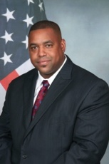
The Sheriff is the Chief Law Enforcement Officer of the county. He is responsible for all law enforcement duties, maintaining the jail, and providing court services.

The RCSO is divided into two (2) basic components, Operations and Administration.

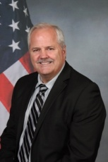
Office of the Chief Deputy
The Chief Deputy provides overall leadership and management of all RCSO operations. Reporting directly to the Chief Deputy are the Field Operations Bureau, comprised of the Patrol divisions and Special Operations Division and the Investigations Bureau, comprised of the Criminal Investigations Division, Vice and Intelligence.

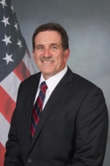
Office of the Colonel
The Colonel provides overall leadership and management of all RCSO administrative and support functions. Reporting directly to the Colonel are the Detention and Court Services Bureau, Office of Professional Standards and Training, Community Services Division, Management Services and Purchasing and Budget Office.

Community-Oriented Policing and Problem Solving (COPPS)

The RCSO is committed to the philosophy and practice of community-oriented policing and problem solving as the fundamental manner in which police services are delivered and community problems are addressed. The term “community policing” refers to both an organizational philosophy and an agency-wide operational strategy which promotes a new and dynamic partnership between the citizens and police. The premise is for both the community and police to work together to identify, prioritize and solve contemporary problems such as crime, fear of crime, social and physical disorder and general neighborhood decay, with the goal of improving the overall quality of life in the community.

Certification and Accreditation
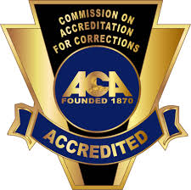

The RCSO became a Georgia state certified law enforcement agency in 2014. In 2016 the RCSO
gained national accreditation through the Commission on Accreditation for Law Enforcement Agencies (CALEA) and the American Correctional Association's Commission on Accreditation for Corrections (ACA). The state certification and national accreditation are the means by which the RCSO complies with the best practices of the law enforcement industry and the ACA insures the compliance of the highest standards in detention and correction. Adhering to these standards of state certification and national accreditation insures the Sheriff’s Office maintains the highest standards and ideals for any law enforcement agency

Fiscal Management

Recent economic challenges have been confronted in order to meet the budgetary constraints of the Commission. The FY 2015 was the same as the FY 2014 budget.

Prudent fiscal management practices associated with strategic planning allows the RCSO to function in 2015 using the budget numbers of 2014. Even in these tight fiscal times, the Sheriff was able to secure a pay increase for over 700 of the 750 employees in an effort to retain the best employees and made the RCSO a more competitive law enforcement agency for recruitment. Current staffing levels indicate:

- 516 full-time allocated law enforcement officer positions
- 234 full-time allocated sworn deputy jailer/civilian positions
(includes jail and law enforcement)

Population Trends

The population of Augusta-Richmond County declined from 199,775 in 2000 to 197,201 in 2016 (estimated by the US Census Bureau). The Richmond County Planning and Development Department projects our 2025 population will be 214,445, a 5% increase from 2016. The Georgia Governor’s Office of Planning and Budget projects our population at 224,620 in 2025, an almost 9% increase from 2016.

*2025 total estimated by Richmond County Planning and Development

Personnel Levels

The current economic challenges are forcing agencies to carefully evaluate their personnel levels and staffing practices. The current staffing level of the RCSO is 2.43 per 1000, known as the “per capita rate” (excludes jail). The national average (per FBI UCR) is 2.8 per capita. With our current per capita rate of law enforcement employees compared to the national average, we are 76 employees short. The Southern per capita rate is 3.3, which would put RCSO 179 law enforcement personnel short.

The RCSO law enforcement officer per capita is 2.12 as compared to the national average of 2.2. That translates to a deficit of 15 deputies. The Southern per capita rate for law enforcement officers is 2.6, which translates to an RCSO deficit of 97 officers.

It should be obvious that we cannot rely solely on the staffing ratio system. We also utilize a manpower and labor allocation data system to determine the amount of resources needed to provide a specific level of professional services. Our ability to sustain our success with lowering crime and fear of crime, while improving the overall quality of life, will be dependent upon the budgetary constraints placed upon us by the Commission.

Calls for Service

*Source: 911 Center via LERMS, Augusta-Richmond County. Starting in 2014 dispatch logs began accounting for all types of labor including proactive and reactive CFS.

Crime Trends

Type of Crime (to date) |  |  |  | 2014 | 2017 | % Change
Homicide |  |  |  | 12 | 17 | 42%
Rape |  |  |  | 52 | 42 | -19%
Commercial Robbery |  |  |  | 29 | 39 | 34%
Residential Robbery |  |  |  | 42 | 13 | -69%
Street Robbery |  |  |  | 104 | 59 | -43%
Other Robbery |  |  |  | 102 | 57 | -44%
Aggravated Assault w/Gun |  |  |  | 69 | 77 | 12%
Aggravated Assault w/out Gun |  |  |  | 70 | 51 | -27%
Total Violent Crime |  |  |  | 480 | 355 | -26%
2nd Degree Burglary |  |  |  | 404 | 192 | -52%
1st Degree Burglary |  |  |  | 1211 | 742 | -39%
Larceny Auto |  |  |  | 925 | 937 | 1%
Auto Theft |  |  |  | 564 | 382 | -32%
Total Property Crimes |  |  |  | 3104 | 2253 | -27%
Total Part I Crimes |  |  |  | 3584 | 2608 | -27%

Traffic Accident Data

Category | 2014 | 2015 | 2016 | 2017**
Crashes | 9,377 | 10,044 | 10,497 | 7,271
Injuries | 2,891 | 3,329 | 3,489 | 2,540
Fatalities | 29 | 28 | 18 | 17
** thru July

VISION STATEMENT

We, the Richmond County Sheriff’s Office, are committed to providing the highest level of public service while practicing the ultimate ideals of law enforcement excellence. Using our philosophy of community-oriented policing and problem-solving, we will partner with the community to provide compassionate service with a “can-do” spirit and integrity.

MISSION STATEMENT

The mission of the Richmond County Sheriff’s Office is to work collaboratively with the community to prevent crime and disorder, solved related problems, reduce fear of crime and enforce the laws according to the U.S. Constitution in order to provide a safe and secure environment for all citizens of this great county.

VALUES – Doing things RITE, Doing the RITE things.

- Respect – Everyone at the Richmond County Sheriff’s Office shares in the recognition that all people are to be treated respectfully.

- Integrity – Each member of the Richmond County Sheriff’s Office has a solemn commitment to maintain the highest levels of personal and organizational integrity.

- Teamwork – No single member of the Richmond County Sheriff’s Office can do their job without the unwavering assistance from other members of the agency. Together, we can accomplish more than a group of individuals working alone.

- Excellence – We strive to perform our very best in every aspect of our operations, providing exceptional service to the community, dedicated to nothing less than the best we can do.

SWOT Analysis

Strengths |  |  |  | Weaknesses
•Strong enforcement |  |  |  | •Leadership Development
of laws |  |  |  | •Kingdom Building
•Positive Public |  |  |  | •Poor Customer Service
•Relations Efforts |  |  |  | by some employees
•Problem-Solving Skills |  |  |  | •Employee Retention
•Training |  |  |  | •Accountability
Opportunities |  |  |  | Threats
•Better Communications |  |  |  | •Continue to
•Promote Retention |  |  |  | lose good
through better pay |  |  |  | employees
and benefits |  |  |  | •Flat tax base
•Career Development |  |  |  | •Technology snafus
•Build the Brand |  |  |  | and limitations
 |  |  |  | •Employee misbehavior

LONG-TERM STRATEGIC GOALS

CRIME – First and foremost, the public expects their Sheriff’s Office to promote community safety by reducing crime. Citizens and visitors want to feel safe and reduce the chance of becoming a victim of a crime.

TRAFFIC SAFETY – Studies consistently show that more people are injured and killed in traffic crashes than all homicides and assaults in our community. The community expects their Sheriff’s Office to promote safe roadways.

ETHICS AND EXCELLENCE – The public entrusts and invents key resources in their Sheriff’s Office as we have been granted the authority to make arrests and use reasonable force. Such authority demands the highest ethical standards and stringent adherence to ethical behavior by all Sheriff’s Office employees.

FISCAL RESPONSIBILITY – The second key resource that the public entrusts and invests with us is municipal tax dollars paid for by the expressed purpose of providing professional law enforcement services. As such, we have a responsibility to use those tax dollars in a prudent manner to deliver exceptional services that consistently meets and exceeds public expectations.

PARTNERSHIPS - Providing a safe community is not a responsibility limited to the RCSO. Other government agencies, various service providers and the citizens themselves share in this responsibility. Therefore, a key strategic practice for the RCSO is to work in a collaborative manner with partners throughout the community with a shared commitment to address conditions that give rise to crime, disorder and unsafe roadways.

GOAL ONE: CRIME

Goal 1.1: Reduce crime, the root causes of crime and the fear of crime to enhance the quality of life in Augusta-Richmond County.

Goal 1.2: Reduce violent crime, especially gun-related violence.

Objective 1.1: Utilize a comprehensive community policy approach to engage residents, businesses, and relevant stakeholders in a wide variety of crime prevention strategies to prevent crime from occurring.

Objective 1.2: Conduct, at a minimum, weekly crime reviews using the CompStat process to identify emerging crime patterns and trends.

Objective 1.3: Deploy resources and design problems specific strategies in “hot-spot” areas where crime patterns and trends are evident.

Objective 1.4: Provide general crime data to the community and specific analytical information to field operations personnel through various technologies.

Objective 1.5: Expand directed activities to reduce gang activity throughout the community.

Objective 1.6: Expand initiatives to remove illegal guns and reduce gun violence through our “No One Wins” campaign.

Objective 1.7: Improve the quality of all criminal investigations through a constant process improvement approach.

KEY PERFORMANCE MEASURES

- Uniform Crime Report (UCR) Part One Statistics
- Gang data
- Arrest statistics
- UCR clearance rates

GOAL TWO: TRAFFIC SAFETY

Goal 2.1: Reduce the number of traffic crashes.

Goal 2.2: Reduce the number of traffic-related injuries.

Goal 3.3: Reduce the number of traffic fatalities.

Objective 2.1: Conduct agency-wide traffic enforcement efforts to promote overall traffic safety.

Objective 2.2: Identify high crash locations through DDACTS methodology and engage in specific engineering, educational and enforcement initiatives at these locations.

Objective 2.3: Conduct agency-wide enforcement initiatives to target specific traffic safety violations through the practices of checkpoints and saturation patrols.

KEY PERFORMANCE MEASURES

- Traffic crash rates
- Traffic crash injury rates
- Traffic crash fatality rates
- Number of traffic citations issued
- Number of traffic warnings issued

GOAL THREE: ETHICS AND EXCELLENCE

Goal 3.1: Promote ethical behavior among all employees.

Goal 3.2: Promote excellence as the only acceptable standard of performance.

Objective 3.1: Increase citizen satisfaction with law enforcement services provided by the RCSO as measured through various customer service surveys.

Objective 3.2: Conduct annual ethics training for all employees.

Objective 3.3: Work on attaining CALEA accreditation status.

Objective 3.4: Implement a process for internal review of performance management to ensure the highest levels of quality service.

Objective 3.5: Reward employee excellence through our Awards, Commendations, and Recognition program.

Objective 3.6: Ensure all investigations into citizen complaints are conducted in an unbiased, objective and transparent manner.

KEY PERFOMANCE MEASURES

- Citizen ratings in customer service surveys.
- Number of complaints filed.
- Number of letters of appreciation received.
- Compliance with all applicable CALEA standards.
- Completion of quality service performance reviews through staff inspections.

GOAL FOUR: FISCAL RESPONSIBILITY

Goal 4.1: Promote prudent fiscal operations to produce cost-effective law enforcement services for the community.

Objective 4.1: Promote outcome-based budgeting that holds the commanders accountable for overall performance outcomes.

Objective 4.2: Conduct annual workload assessments and personal deployment strategies to ensure cost-effectiveness.

Objective 4.3: Promote system efficiency reviews to develop process improvements.

Objective 4.4: Continually seek alternative funding sources through grants and collaborative contributions.

KEY PERFORMANCE MEASURES

- Completion of annual workload assessments by Division Commanders.
- Completion of systems efficiency reviews.
- Measure total amount of annual grant funding.
- Measure total amount of collaborative contributions.
- Measure of overall budget expenditures.

GOAL FIVE: PARTNERSHIPS

Goal 5.1: Promote collaborative partnerships as the most efficient way to maintain order and improve the community’s quality of life.

Objective 5.1: Improve the quality and quantity of collaborative partnerships to reduce crime, improve traffic safety, maintain order and establish a high quality of life for all citizens.

Objective 5.2: Maintain a collaborative partnership with all Neighborhood Associations and relevant stakeholders.

Objective 5.3: Increase our collaborative involvement with the County Commission and other government agencies and departments.

Objective 5.4: Promote a spirit of selfless volunteerism among employees to give back to our community.

Objective 5.5: Foster an environment that recognizes and values every member’s contribution to our mission.

Objective 5.6: Expand the involvement of citizen volunteers in the delivery of law enforcement services.

KEY PERFORMANCE MEASURES

- Measure quantity of collaborative partnerships.
- Conduct periodic meetings with members of the Sheriff’s Advisory Board.
- Measure number of Neighborhood Association meetings attended by members of RCSO.
- Measure number of citizen volunteer hours.
- Measure number of hours spent by members of RCSO with other government agencies and departments.

